**The Survival Kit**

**Task**: - Finding a temporary shelter place.

**Prototype**: -

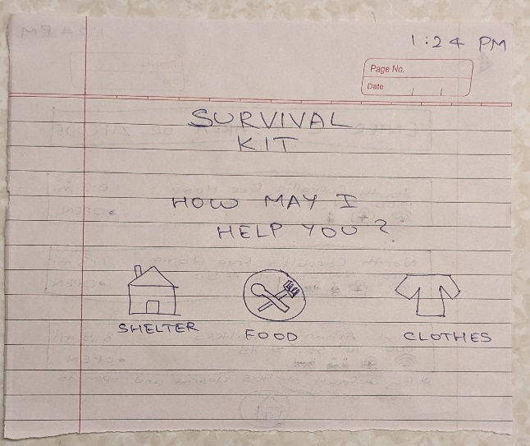

**Feedback**: -

The following issue were raised by my partner during the above activity.

1. There could have been details for icons shown in screen two. The icons were not clearly visible, and so the observer found it difficult to interpret it’s meaning and significance.
2. The user mentioned that a “search button” was not visible in the second screen. He further stated that this could lead to issue with respect to certain functionality that the user might be expecting.
3. On the third screen, user stated that it would be better if icons/symbols were drawn next to the names under facilities since it would help a user identify and understand it easily.
4. The user was confused regarding the next transition screen/process when the home button on screens 2 and 3 were pressed. So, making it different than the shelter icon as seen on the home screen would make it easy for the user to navigate through the application.